PEMBRIDGE CE PRIMARY SCHOOL LEARNING JOURNEY KEYS
Pembridge is a school where we encourage everyone to be inspired through faith in God and to live by Christian values so that our teaching and learning is of the highest quality,
our whole community flourishes and we reflect all that is worthy of praise.
SUBJECT: R.E. |  | YEAR: B |  | TERM: Summer 1 |  | YEAR GROUPS: Y1/ 2
KEY QUESTION: What makes some places sacred to believers?
Question | Vocabulary to use |  | Information which will help me |  | Can I…?
Which place of worship is sacred to Christians? | church  Christian  sacred  Priest  Rabbi  Jew  Where can I find the lectern? What is its purpose?  synagogue  community |  | 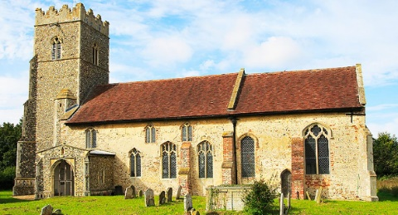  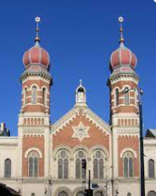  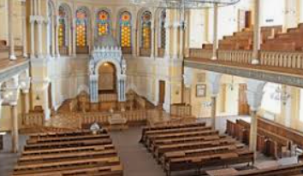  Are there any similarities between a church and a synagogue? |  | - Give an example of a place of worship that is significant to Pembridge and say why it is important?  - Give examples of objects that might be found in a Church and describe what the objects mean or how they are used?  - Give examples of what people do in a Church and why they do it?  - Give examples of what people do in a Synagogue and why they do it and describe how objects are used in Jewish worship?  - Giving reasons that a person might want to belong to a place of worship?
Why are places of worship sacred to Christians?
How are places of worship similar and different?
Why are places of worship important to our community?
What makes some places sacred to believers?
Christian Timeline


