PEMBRIDGE CE PRIMARY SCHOOL LEARNING JOURNEY KEYS
Pembridge is a school where we encourage everyone to be inspired through faith in God and to live by Christian values so that our teaching and learning is of the highest quality, our whole community flourishes and we reflect all that is worthy of praise.
SUBJECT: History |  | YEAR: A |  | TERM: Spring 1 | YEAR GROUPS: 3/4
KEY QUESTION: How were the Maya different to us?
Question | Vocabulary to use |  | Information which will help me |  |  | Can I…?
Who were the Maya? | alliances  cacao beans  calendar  Central America  chocolate  dynasty  Empire  Gods  hieroglyphics  hunting  maize  Mexico  pyramid  ritual  sacrifice  settlement  Pakal the Great  temple  trade  tradition  worship |  | 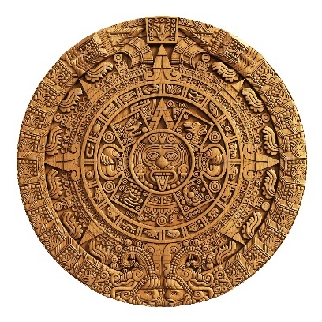  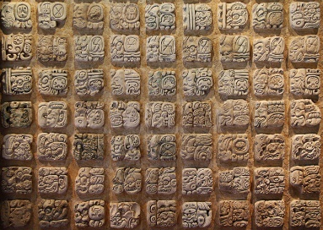  What would this make?  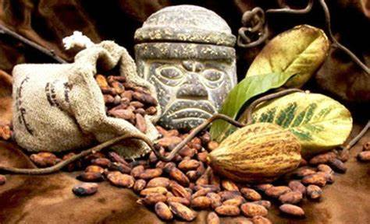  Do you recognise these Maya artefacts?  Do we use them, or a version of them, today?  Maya Temple in Tikal, Guatemala  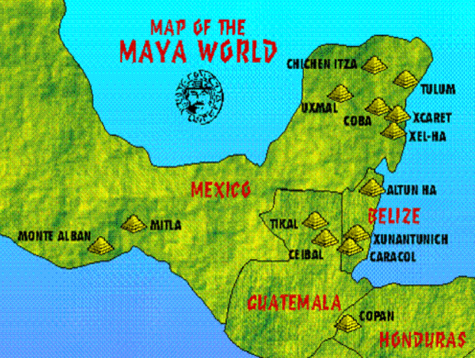  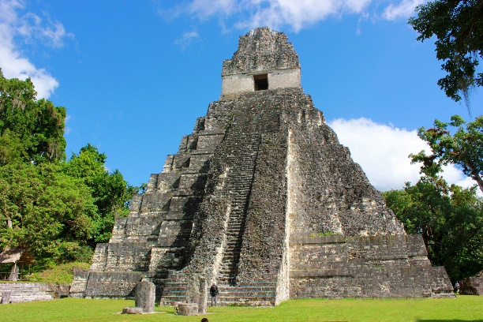 |  |  | - Place the Ancient Maya Civilisation on a timeline in relation to other periods;  - Use different sources to find out about the Maya;  - Consider the reliability of different sources;  - Take notes from different sources in order to gather information;  - Use specific vocabulary when talking about the Maya;  - Explain why the Ancient Maya Civilisation ended.
Who did they follow: rulers and religion?
What did everyday life look like?
Where did they go?
Timeline of Ancient Mayan Civilisation
2500 BC  Start of the Ancient Maya Civilisation. | 400BC  The first ancient Solar calendars are carved into stone. | 500AD  The great city of Tikal becomes the first great Maya city. | 683AD  Pakal the Great, one of the most famous Maya rulers, dies. | 751AD  Alliances break down and trade between Maya cities declines. | 910 AD  End of the Ancient Maya Civilisation.

