PEMBRIDGE CE PRIMARY SCHOOL LEARNING JOURNEY KEYS
Pembridge is a school where we encourage everyone to be inspired through faith in God and to live by Christian values so that our teaching and learning is of the highest quality, our whole community flourishes and we reflect all that is worthy of praise.
SUBJECT: Science (biology) |  | YEAR: B |  | TERM: Summer 2 | YEAR GROUPS: Y1/ 2
KEY QUESTION: What different habitats are there on planet earth?
Question | Vocabulary to use |  | Information which will help me |  |  | Can I…?
Living, dead or never been alive? | alive  food source  habitat  ocean  polar  survive  woodland |  | 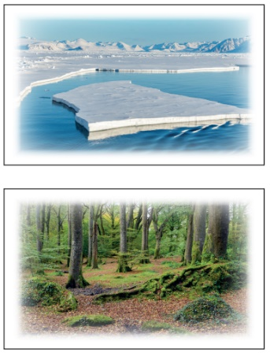  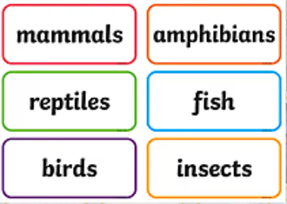  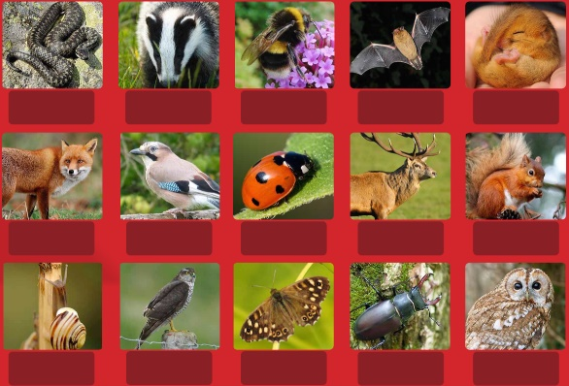  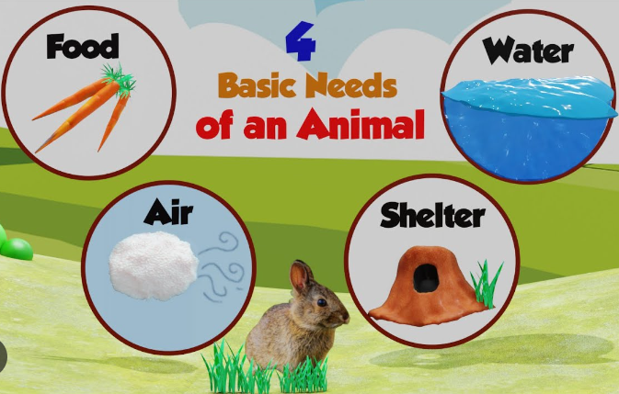  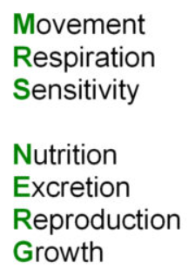  How many of these exist within our country?  Habitat:  a natural environment or home of a variety of plants and animals. |  |  | - identify and name a variety of plants and animals in their habitats?  - know which animals and plants are suited to a polar, woodland or ocean habitat?  - create my own line of enquiry and consider how I might find an answer / collect data?  How do different habitats provide for the basic needs of these animals? How do they depend on each other?
What is a local habitat?
What animals and plants live in polar habitats?
Are all animals that live in seas and oceans fish?
What lives in a woodland habitat?

