PEMBRIDGE CE PRIMARY SCHOOL LEARNING JOURNEY KEYS
Pembridge is a school where we encourage everyone to be inspired through faith in God and to live by Christian values so that our teaching and learning is of the highest quality, our whole community flourishes and we reflect all that is worthy of praise.
SUBJECT: Science (biology) |  | YEAR: B |  | TERM: Summer 1 | YEAR GROUPS: Y1/ 2
KEY QUESTION:How can we control the growth of a plant?
Question | Vocabulary to use |  | Information which will help me |  |  | Can I…?
Are all plants the same?  Bulb or seed?  What do plants need to grow?  Can a plant grow in the dark?  How does temperature affect the growth of plants? | branch  bulb  flower (blossom)  fruit  leaf  petal  roots  seed  stem  trunk |  | 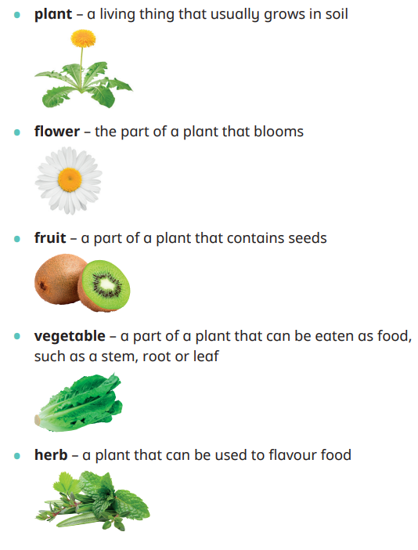  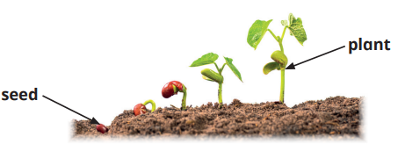  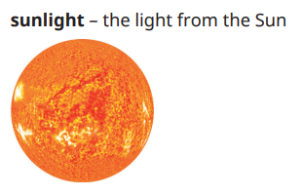  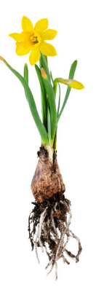  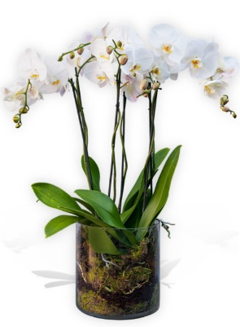  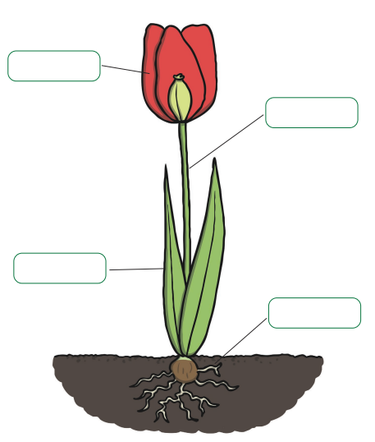  How does sunlight affect the growth of plants?  What is the same, what is different?  Do all flowering plants have the same parts? What are they called? |  |  | - Name the main parts of a flowering plant: petals, stem, leaf, bulb, flower, seed and root?  - Sort and group parts of different plants?  - Classify plants that grow from bulbs?  - Know what things a plant needs to grow and stay healthy?  - Set up an investigation that is fair?  - Make observations about my growing plant noting its size and any changes in colour?

