PEMBRIDGE CE PRIMARY SCHOOL LEARNING JOURNEY KEY
Pembridge is a school where we encourage everyone to be inspired through faith in God and to live by Christian values so that our teaching and learning is of the highest quality, our whole community flourishes and we reflect all that is worthy of praise.
SUBJECT: Science (biology) |  | YEAR: B |  | TERM: Summer | YEAR GROUPS: 5/6
KEY QUESTION: Why can’t I roll my tongue?
Question | Vocabulary to use |  | Information which will help me |  |  | Can I…?
How can we find out about variation in different organisms? | adaptation  adaptive  characteristics  classification  common ancestor  environment  evolution  extinction  fossils  fossil record  habitat  inheritance  invertebrates  natural selection  offspring  organism  species  trait  vertebrates  variation |  | 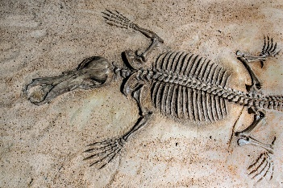  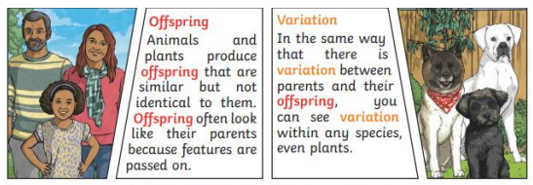  Fossils are the preserved remains of ancient animals and plants. They show us how organisms looked millions of years ago and prove how living things have evolved.  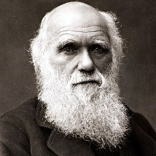  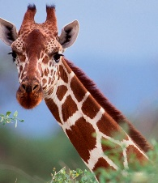  Charles Dawin was a scientist whose observations led him to the theory of evolution by natural selection. This meant that the organisms which were best able to adapt to their environment, would be the ones most likely to survive.  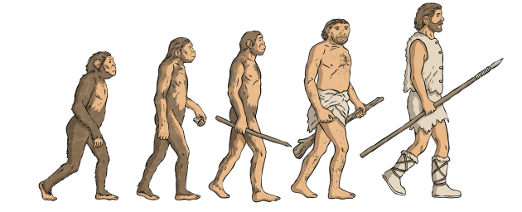  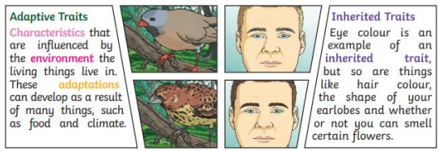  An example of natural selection: fossils show that giraffes used to have shorter necks but these have evolved becoming longer to enable them to reach the higher branches of trees.  Evolution is the gradual process by which living organisms have developed from earlier forms over millions of years. Even today, living things continue to evolve. |  |  | - Identify and describe variations in different organisms using key vocabulary?  - Identify characteristics likely to be inherited and describe what is meant by ‘desired characteristics’?  - Describe how different organisms are adapted to their environment?  - Explain what evolution is and how the ability to adapt makes the survival of a species much more likely while relating this to Darwin’s ideas about ‘natural selection’?  - Describe how fossils are formed; how this helps to support the theory of evolution; and how this links to Darwin’s idea of ‘common ancestors’?  Explain what evolution is and how the ability to adapt makes the survival of a species much more likely?  - Describe the stages of fossil formation and the importance of the fossil record in adding to our knowledge and understanding of evolution?
How oes inheritance affect the characteristics of organisms?
What os the significance 0f adaptation?
How can we explore Darwin’s theory of evolution?
What are fossils and how do they provide evidence for evolution?

