PEMBRIDGE CE PRIMARY SCHOOL LEARNING JOURNEY KEY
Pembridge is a school where we encourage everyone to be inspired through faith in God and to live by Christian values
so that our teaching and learning is of the highest quality, our whole community flourishes and we reflect all that is worthy of praise.
SUBJECT: Science (biology) |  | YEAR: B |  | TERM: Spring 2 | YEAR GROUPS: 3/4
KEY QUESTION: What keeps me upright?
Question | Vocabulary to use |  | Information which will help me |  |  | Can I…?
What are the names of some bones in the skeleton and what are their functions? | backbone  ball and socket  biceps  endoskeleton  exoskeleton  femur  invertebrate  joint  hinge  muscles  pelvis  protection  ribcage  skeleton  skull  spine  support  triceps  vertebrate |  | 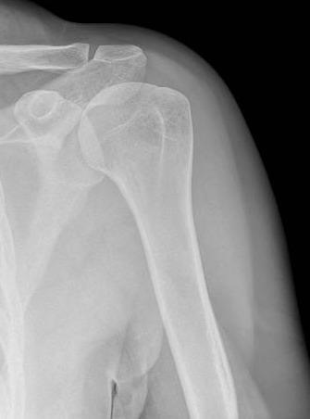  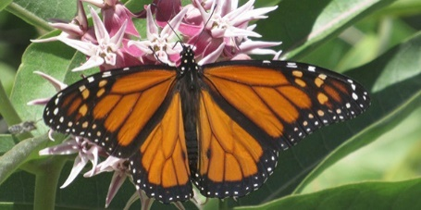  A human skeleton has three main functions: to support the body, to enable movement and to protect vital organs. Humans are called vertebrates because they have a spine or backbone. What other creatures have backbones? A skeleton on the inside of the body is called an endoskeleton.  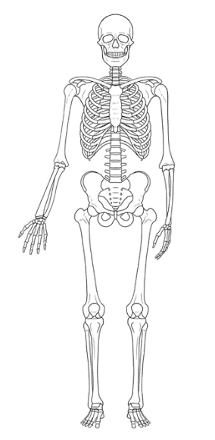  Creatures without backbones are called invertebrates. Some, like this butterfly and centipede, have exoskeletons. An exoskeleton is on the outside of the creature’s body.  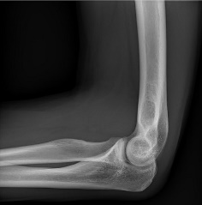  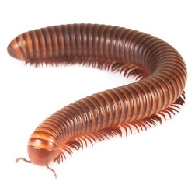  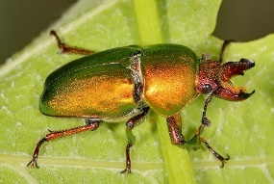  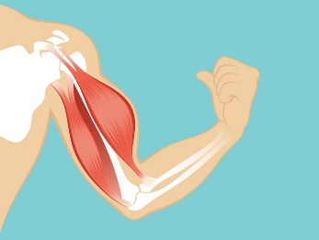  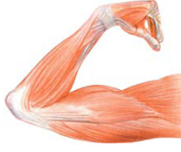  There are several types of joint in the skeleton. Here, one is a hinge joint and the other is a ball and socket joint.  Muscles are attached to the skeleton. They create movement by relaxing and contracting. |  |  | - Identify the functions of the skeleton including the names of parts of the skeleton including those that protect vital organs.  - Identify different joints of a skeleton and describe how they allow movement.  Explain that muscles work in  pairs and describe the  relaxation and the contraction  of muscles and the effects of  these.  - Identify that humans and some other animals have bony skeletons as well as muscles for support, protection and movement.  - Identify the skeletons of vertebrates and invertebrates and explain the differences.  - Explain what has been learned and decide on ways of grouping animals according to their skeleton.
What are joints and how do muscles and joints enable movement?
How can we identify and name bones in a range of animals?
How can we compare different types of skeleton?
Are all skeletons the same?

