PEMBRIDGE CE PRIMARY SCHOOL LEARNING JOURNEY KEY
Pembridge is a school where we encourage everyone to be inspired through faith in God and to live by Christian values so that our teaching and learning is of the highest quality, our whole community flourishes and we reflect all that is worthy of praise.
SUBJECT: Science (physics) |  | YEAR: B |  | TERM: Spring 1 | YEAR GROUPS: 5/6
KEY QUESTION: How do forces affect us?
Question | Vocabulary to use |  | Information which will help me |  |  | Can I…?
What is gravity and how can we measure the force that it exerts? | air  balanced  buoyant  buoyancy  compress  compression  effort  energy  force  force meter  friction  Galileo  gravity  lever  lubricant  newton  mass  meter  motion  pivot  pulley  resistance  Sir Isaac Newton  streamlined  upthrust  vacuum  weight |  | 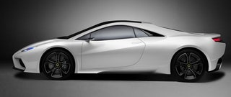  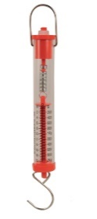  A newton meter measures the force acting upon an object.  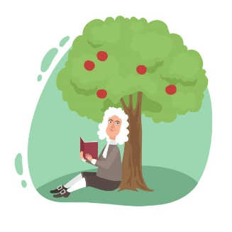  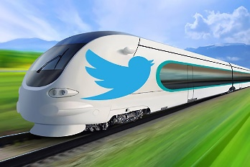  The car and the train are both streamlined. What do you think this means and why might it be important?  Isaac Newton was a scientist who is said to have worked out the theory of gravity when an apple fell on his head.  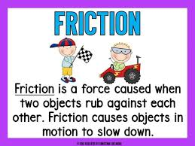  A force called upthrust is being exerted on the yacht. What could be its effect?  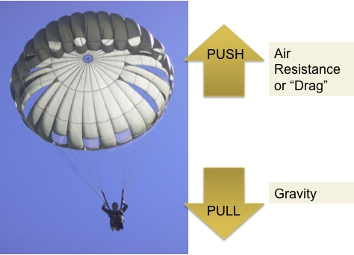  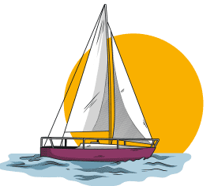  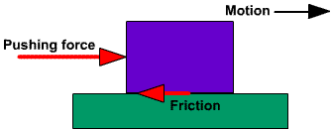 |  |  | - Use a force meter with accuracy and show an understanding of the link between gravity and weight?  - Understand balanced forces and their effect?  - Appreciate the factors that affect air resistance?  - Compare, and change, the effects of movement on different surfaces understanding how to increase, or to reduce, friction?  - Identify pulleys and levers and describe – and measure where possible -  the effect of using them?
How can we investigate the effect of upthrust?
What is air resistance and how can we investigate its effect?
What is the effect of friction and how can its effect be changed?
How can we investigate the mechanical advantage of using pulleys and levers?

