PEMBRIDGE CE PRIMARY SCHOOL LEARNING JOURNEY KEY
Pembridge is a school where we encourage everyone to be inspired through faith in God and to live by Christian values so that our teaching and learning is of the highest quality, our whole community flourishes and we reflect all that is worthy of praise.
SUBJECT: Science (biology) |  | YEAR: B |  | TERM: Spring 1 | YEAR GROUPS: 3/4
KEY QUESTION: Where does my food go?
Question | Vocabulary to use |  | Information which will help me |  |  | Can I…?
Why do we have different types of teeth? | acid  anus  balanced (diet)  canine  carbohydrate  chew  diet  digestion  digestive system  enamel  esophagus  fat  faeces  gastric  gullet  health  healthy  incisor  minerals  molar  nutrition  premolar  protein  saliva  stomach  swallow  vitamins |  | 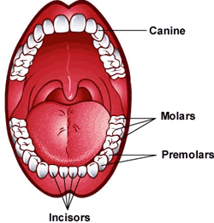  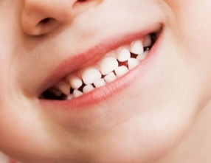  Compare these two sets of teeth. The biggest cause of tooth decay is eating too much sugar but why is this?  Different teeth have different functions. Their function depends on their shape.  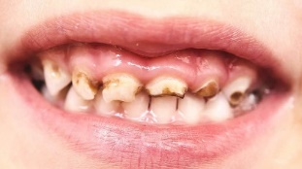  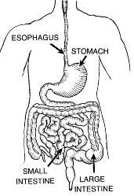  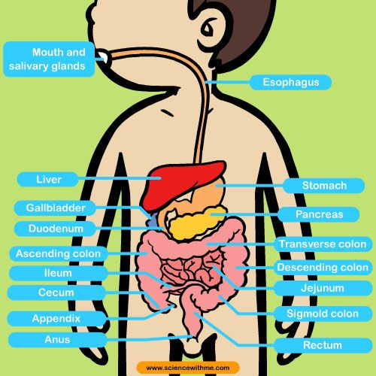  Can you identify some different types of foods on this plate?  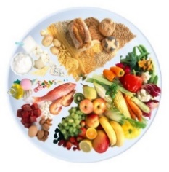  These two diagrams help to show the some parts of the digestive system. |  |  | - Identify different types of teeth in humans and other animals and link them to their functions and diet?  - Understand the effects of sugar and poor dental hygiene and explain the best ways of keeping teeth healthy?  - Link different parts of the digestive system to their functions and explain the purpose of digestion?  - Show an understanding of food groups and how they form a balanced diet?  - Show an awareness of the importance of a balanced diet and how to achieve it?
What is tooth decay and how can it be prevented?
What is the process of digestion?
What food groups make up a balanced diet?
How can we try to ensure that we eat a balanced diet?
 | 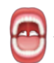 | 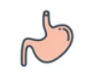 |  |  | 

