PEMBRIDGE CE PRIMARY SCHOOL LEARNING JOURNEY KEY
Pembridge is a school where we encourage everyone to be inspired through faith in God and to live by Christian values so that our teaching and learning is of the highest quality, our whole community flourishes and we reflect all that is worthy of praise.
SUBJECT: Science (physics) |  | YEAR: B |  | TERM: Autumn 2 | YEAR GROUPS: 3/4
KEY QUESTION: Why do I need my ears ?
Question | Vocabulary to use |  | Information which will help me |  |  | Can I…?
What is sound and where do sounds come from? | amplify  amplification  decibel  ears  guitar  hear  high  instruments  loud  loudness  low  muffle  percussion  pitch  quiet  quietness  silent  silence  siof  sound  soundproof  telephone  vibrate  vibration  violin |  |   What is a vibration? What have vibrations got to do with sound and hearing?  Could there be a reason for our ears being shaped in the way?  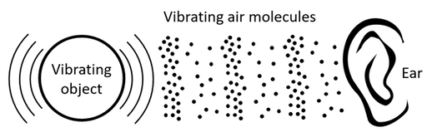  A short pipe (tube) produces a different pitch to a long pipe (tube).    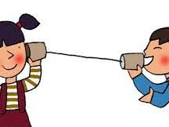  This is a string telephone. How does it work?  These brass instruments have been organized in order according to pitch.  How many instrments can you think of?    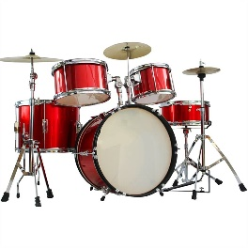  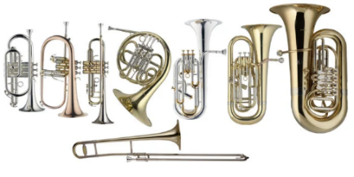  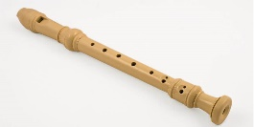 |  |  | - Identify particular sounds, understand that all sounds stem from movement and start to appreciate how our ears ‘collect’ sound?  - Recognise and describe, vibrations and explain their link with sound?  - Suggest ways of carrying out an investigation and understand that sound becomes fainter with distance?  - Recognise changes in pitch and, through systematic enquiry, discover and explainhow low and high piches may be produced?  - Help to devise an investigation, carry it out, make judgements about sound and describe or explain results?
What are vibrations and what link do they have with sound?
How can we investigate how far sound will travel?
What is pitch and how can it be changed?
How can we find the best way of making a string telephone?

