PEMBRIDGE CE PRIMARY SCHOOL LEARNING JOURNEY KEY
Pembridge is a school where we encourage everyone to be inspired through faith in God and to live by Christian values so that our teaching and learning is of the highest quality, our whole community flourishes and we reflect all that is worthy of praise.
SUBJECT: Science (physics) |  | YEAR: B |  | TERM: Autumn 1 | YEAR GROUPS: 5/6
KEY QUESTION: Do carrots really help you to see in the dark?
Question | Vocabulary to use |  | Information which will help me |  |  | Can I…?
How can we explore light?  (What do we already know or think?) | absorb  colour  concave  convex  eye  iris  lens  light  mirror  opaque  optical  periscope  pupil  reflection  reflective  refraction  shadow  source  spectrum  translucent  transparent |  | 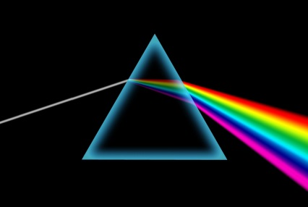  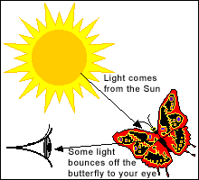  Light reflecting from one mirror to another, is the principle behind a periscope.  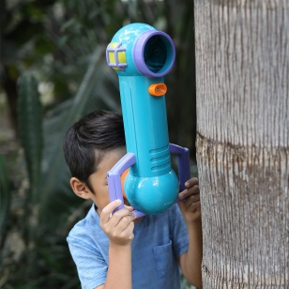  Isaac Newton shone a light through a transparent prism and separated light into the colours of the rainbow - the spectrum. All the colours merge and make visible light.  We see things because light that is reflected from them goes into our eyes.  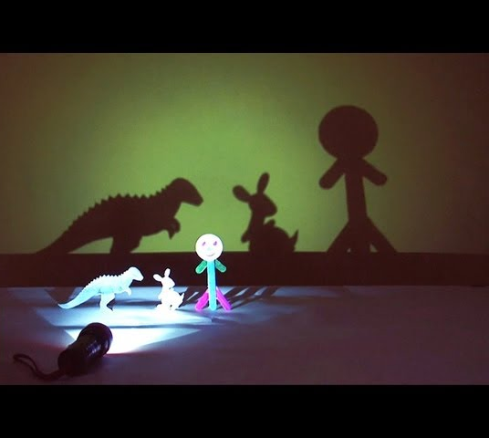  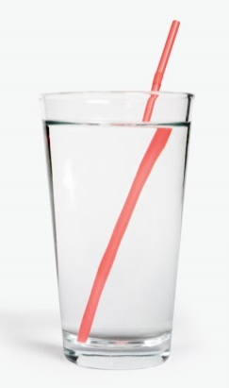  This is an example of refraction, Can you describe what you can see?  A shadow is always the same shape as the object that casts it. |  |  | - Link ideas and make hypotheses using previous knowledge as well as my explorations?  - Carry out an investigation into the changing length and position of shadows, record my results and explain my findings?  - Draw diagrams to explain how we see things and model this; show an understanding of reflected light; and use the idea of it to make a periscope? Make links with the topic question and the history topic on WW2?  - Investigate using a prism to make a spectrum and explore the effect of merging colours?  - Explain what refracton is and the reasons for it?
How do shadows change through the day?
(Movable according to sunlight)
How do we see things?
(include reference to topic question)
How can we explore the spectrum?
What is refraction?
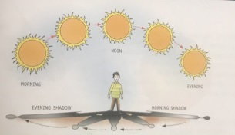 | 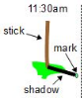 | 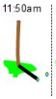 | 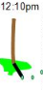 | 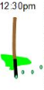 | 

